Microphone Migration for Dragon Medical One
A mixed environment of PowerMic II, PowerMic III, PowerMic 4, and Philips SpeechMike devices can result in users switching back and forth between devices with different button layouts and defaults as they move between workstations.

Best practices
- Avoid mixed environments. When possible, all the workstations in a specific area should have the same microphone, even if different areas have different microphones. Consider sourcing enough of a specific device for one area and redistribute the existing devices to other areas.
- If you can’t avoid a mixed environment, try to keep button layouts the same. PowerMic II and III have the same general shape and button layout; PowerMic 4 and Philips SpeechMike have the same general shape and button layout.
- Customize button layout to minimize disruption in mixed environments.

Physical Button Layouts
PowerMic II/III | PowerMic 4 | Philips SpeechMike 3700
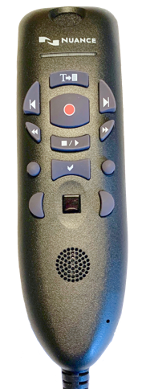 | 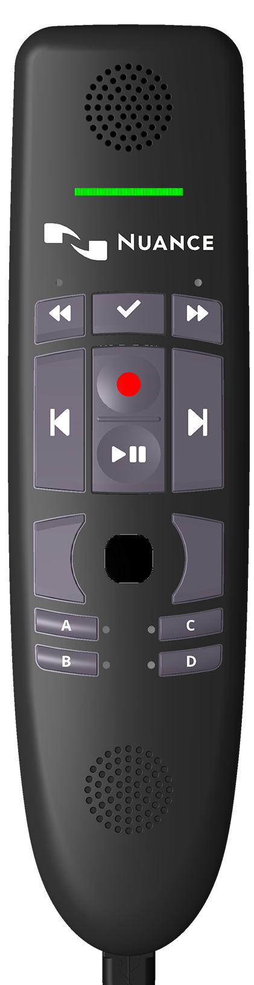 | 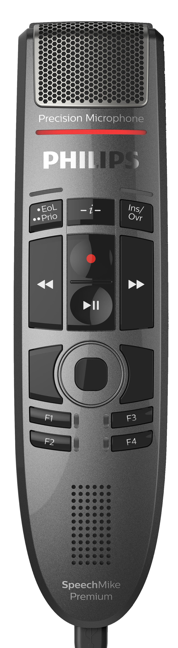
- 2 custom buttons  - Unique button layout | - 5 custom buttons (4 front, 1 rear)  - Same layout as SpeechMike with different lables | - 5 custom buttons (3 front, 1 rear)  - Same layout as PowerMic 4 with different lables  - F3 and “-i-” are unsupported
Default Button Mapping
Each device has a set of defaults for Dragon Medical One. These can be managed either individually in the DMO Options panel or for multiple users via the Nuance Management Center.
- The Record button is the same on all devices. There are only two settings available: Press-and-hold (mic is on only while the button is pressed down) and on/off (button is a mic on/off toggle).
- All of the other buttons have a default function but can be changed to any available function.

PowerMic III
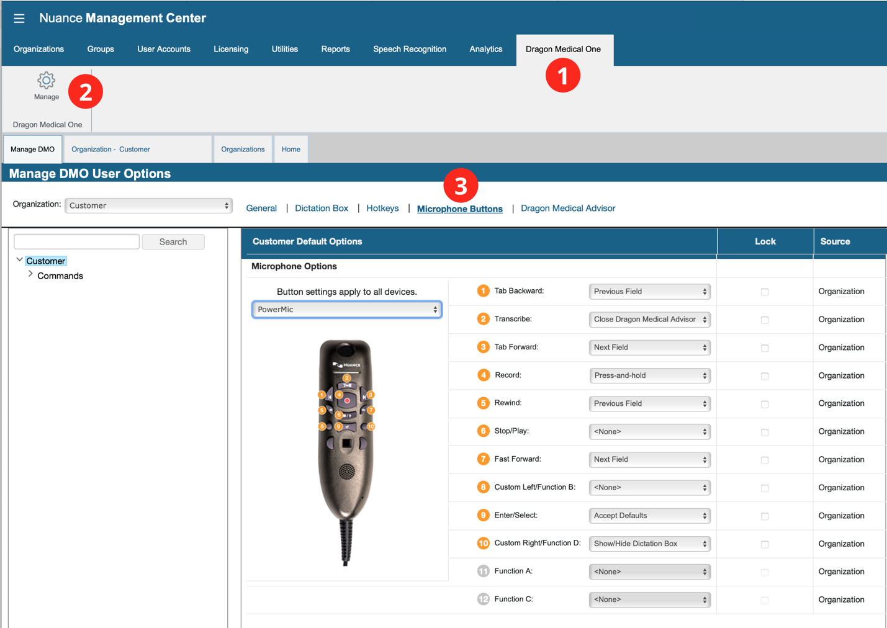
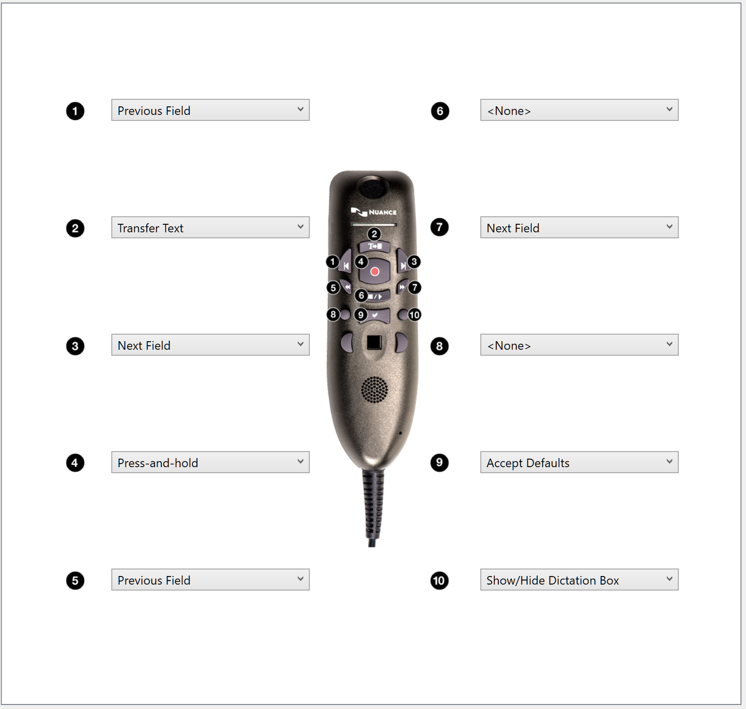
PowerMic 4
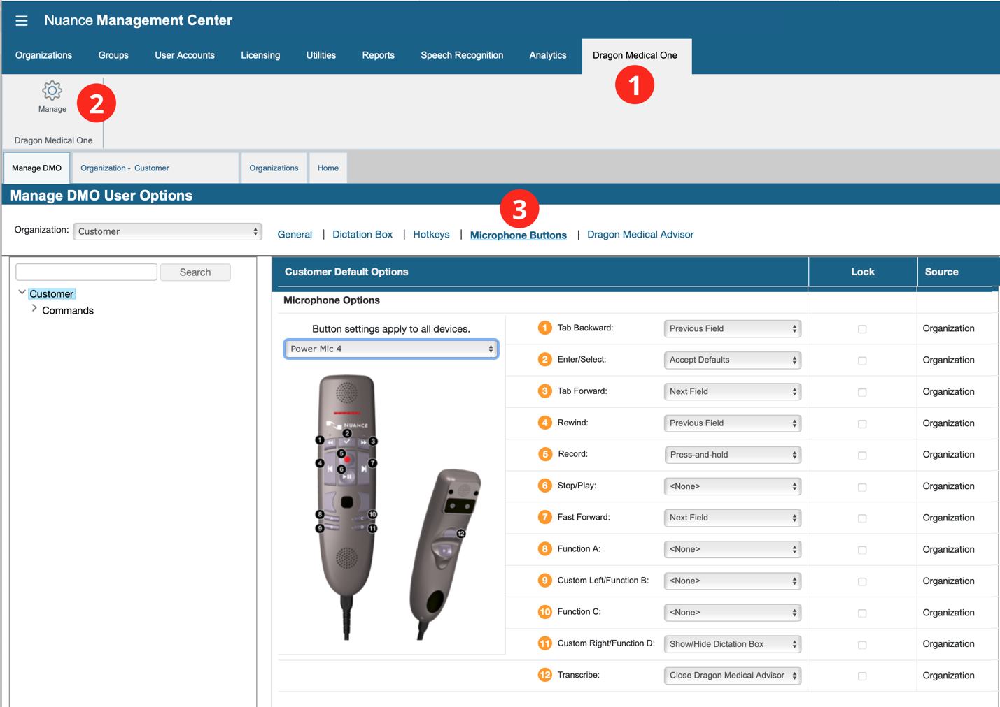
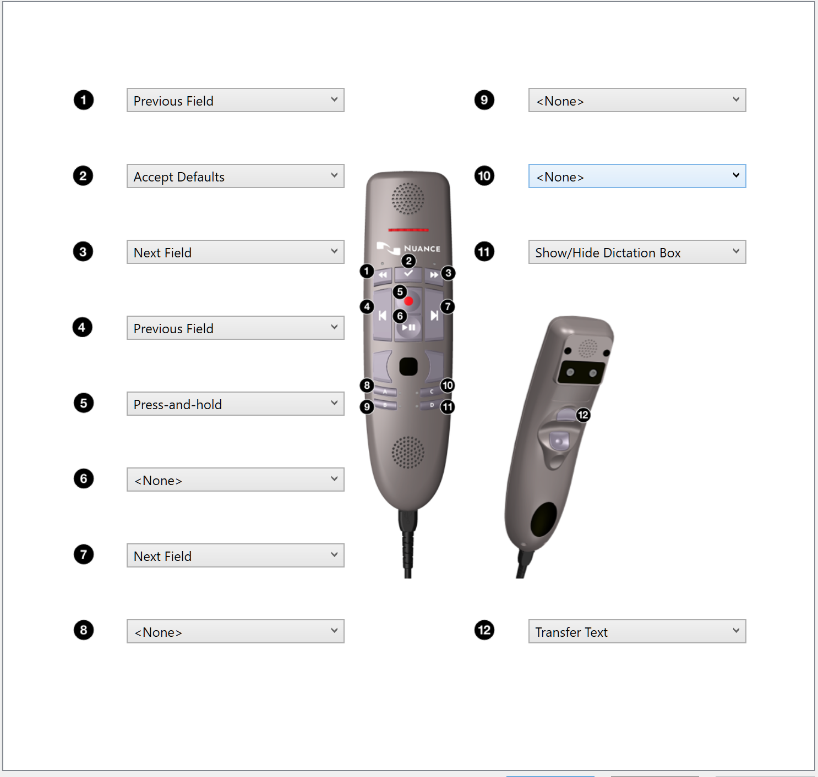
SpeechMike
